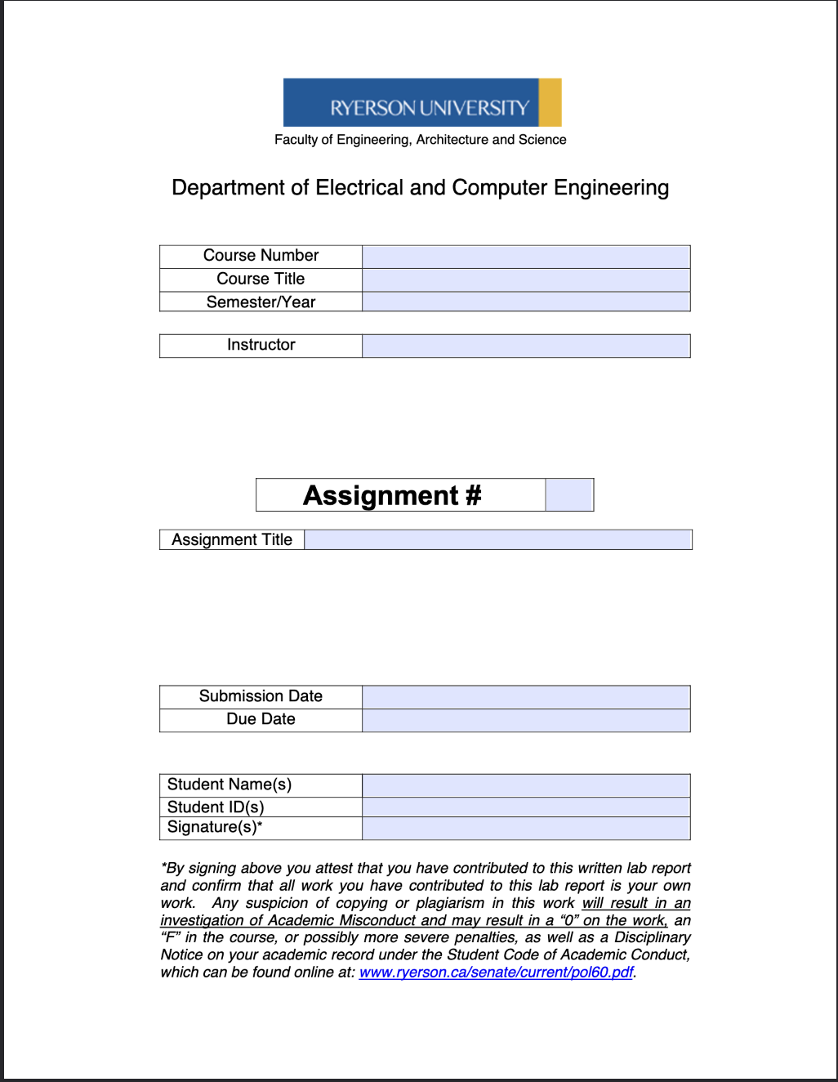
ELE504
Electronic Circuits II
F2024
Dr. Rueda
MP
ELE504 MP Lab Report 1
October 2nd, 2024
October 3rd, 2024
Shai Mourad/Jason Fu
501170415/501035603
SM/JF

Table of Content
1. Introduction...........................................................................................R2
2. Circuit under Test..................................................................................R2
3. Experimental Results............................................................................R3
4. Conclusions and Remarks.....................................................................R4
5. Appendix…………………………………………...............................R4

Introduction
For this lab experiment, the first portion of the major project was completed. An inverting integrator was placed in series with a non-inverting bistable multivibrator to create a waveform generator. Using the design for a waveform generator from the pre-lab for a specific f_{x} value, the circuit was implemented on a breadboard to output a square and triangular waveform with proper output values. This lab took place on October 2nd, 2024.

Circuit under Test
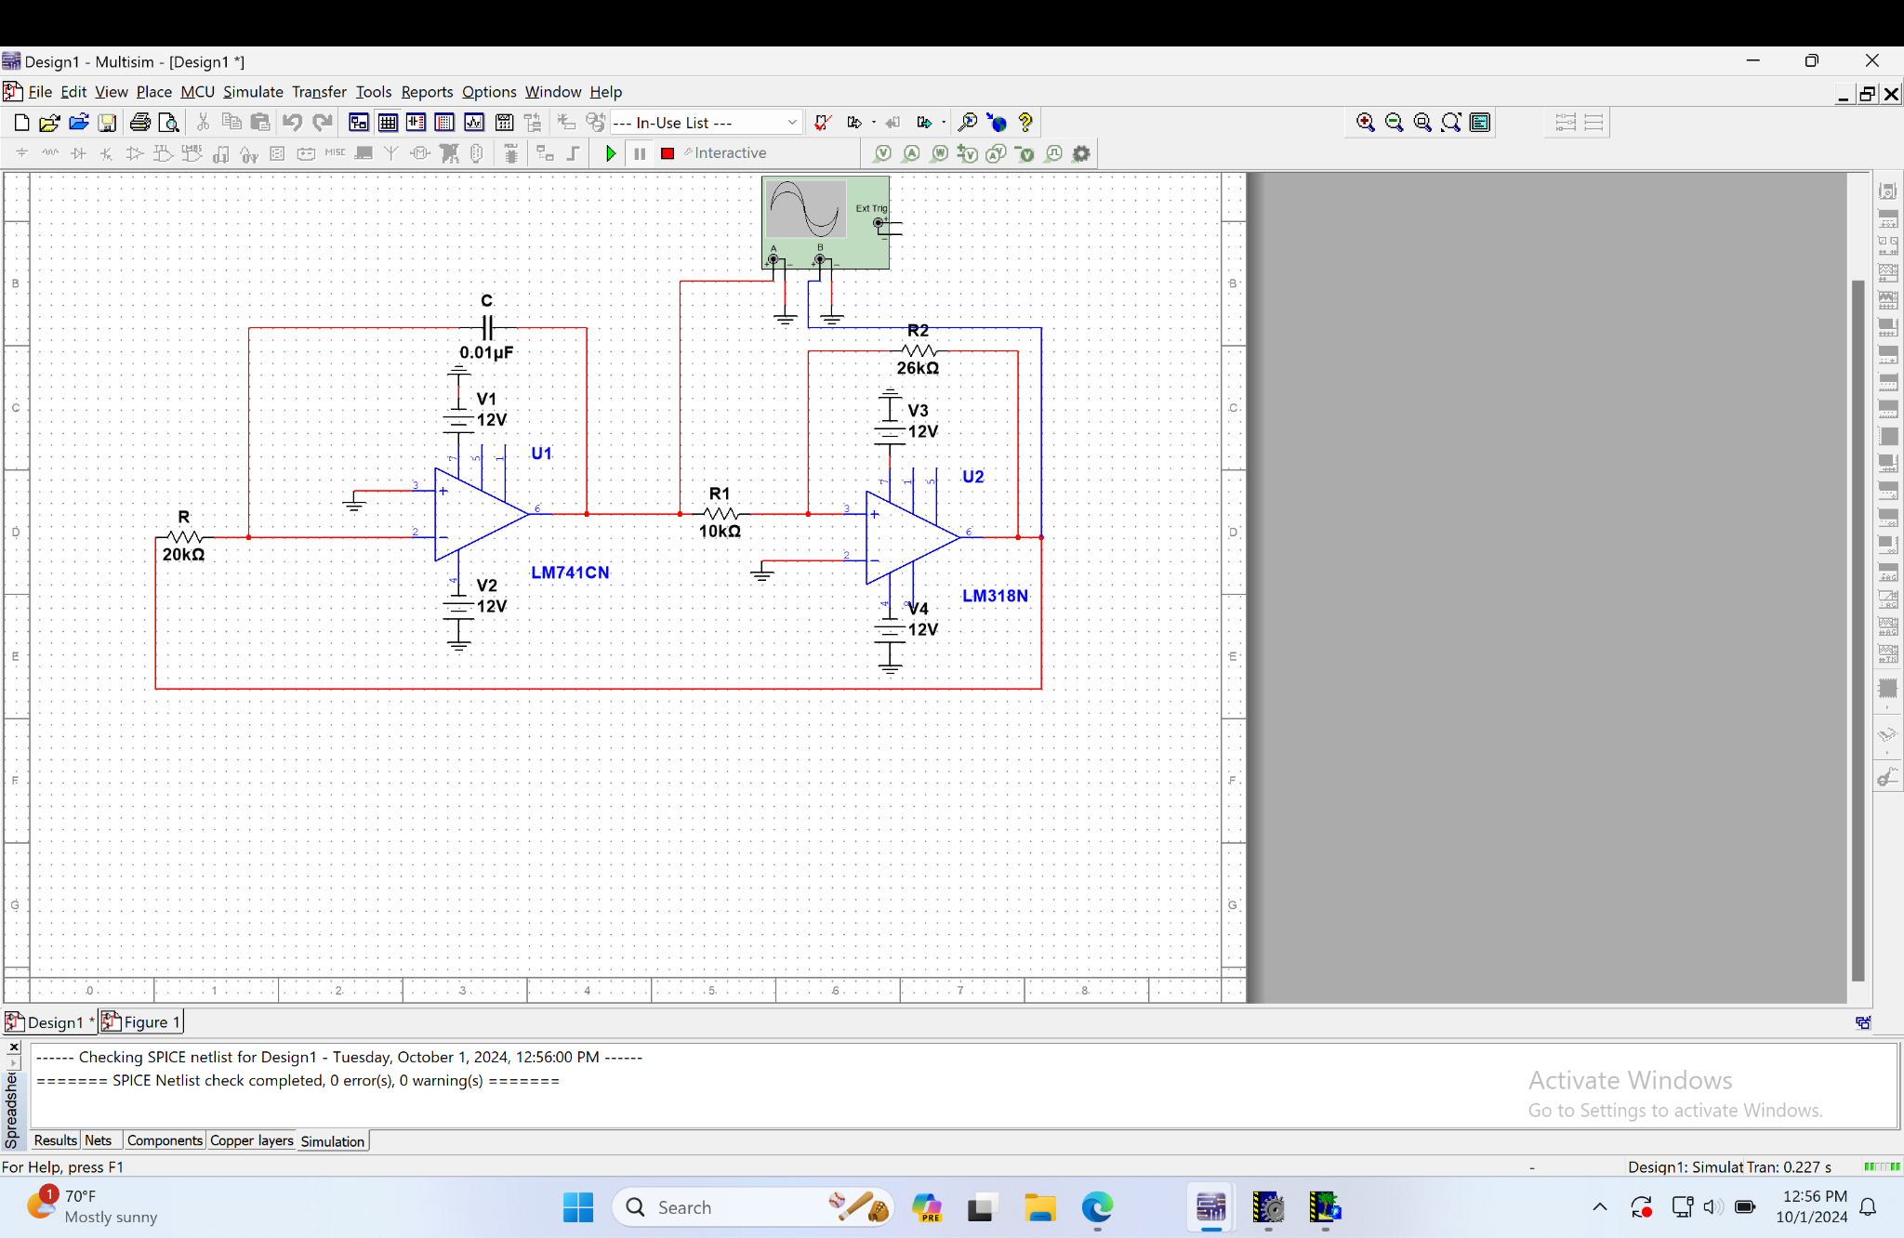
Waveform Generator Design For f_{x} = 3100Hz

Experimental Results

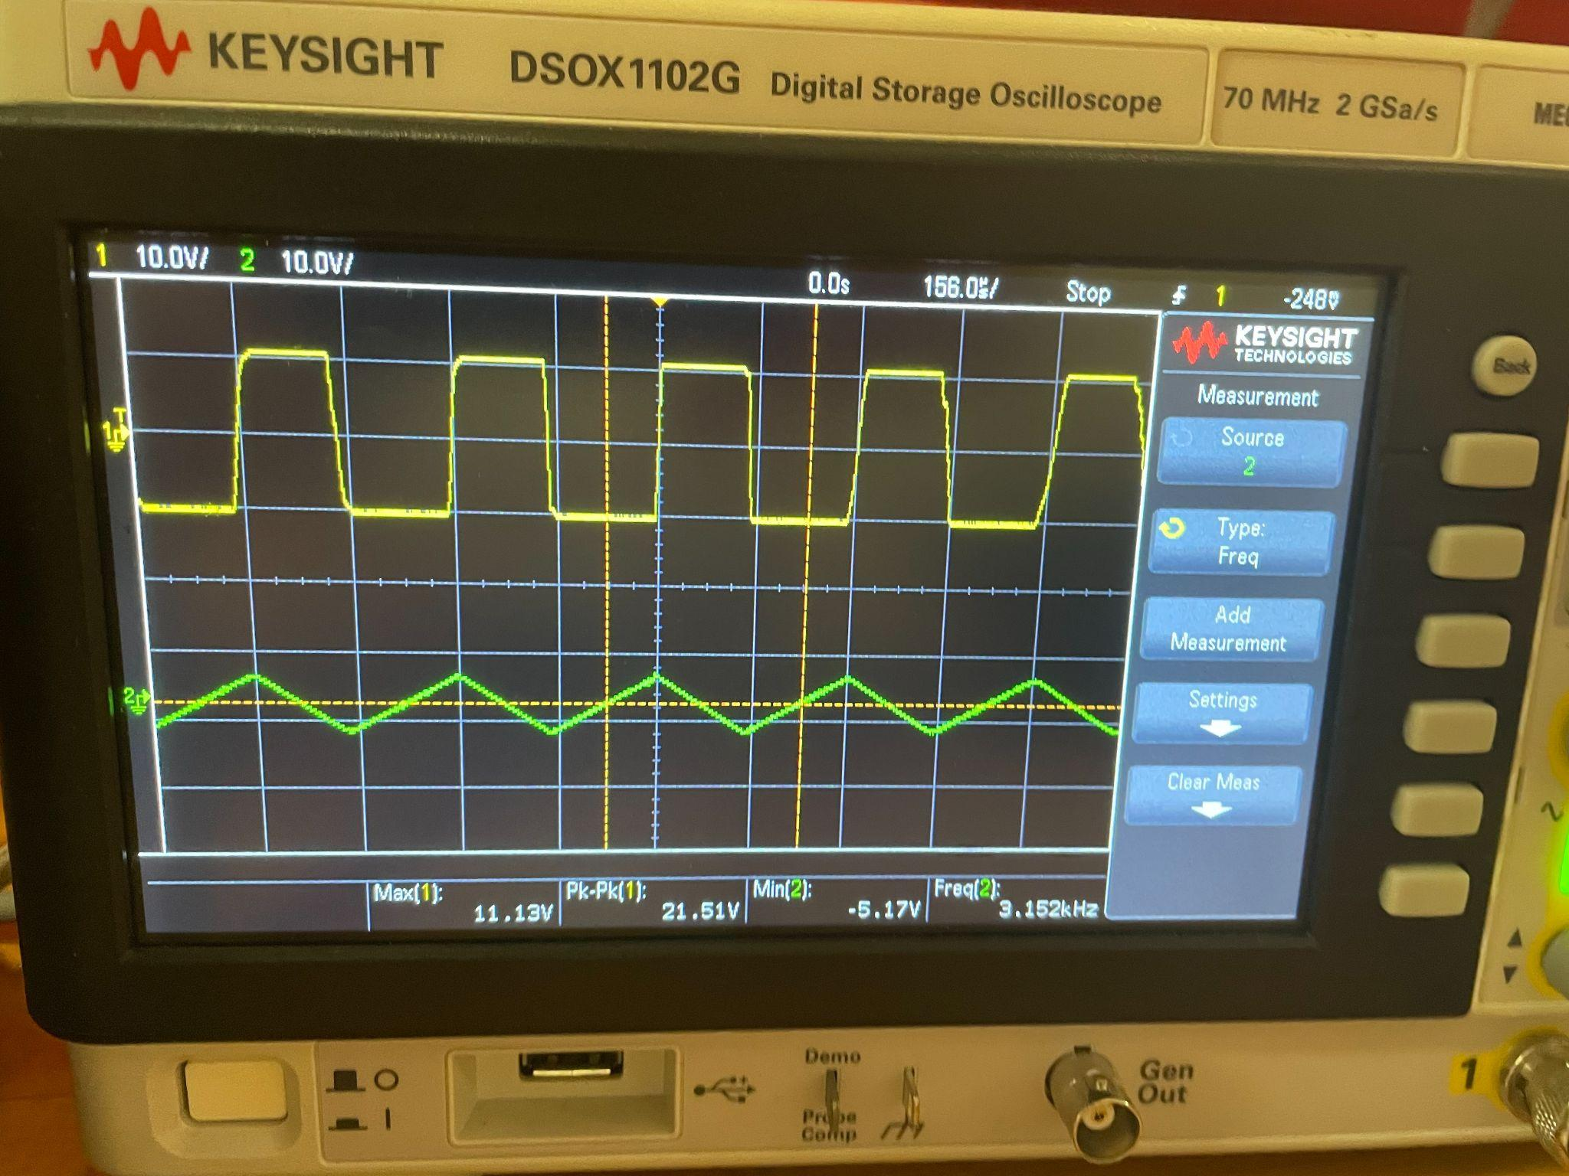
Figure 1. Waveforms of both V_{O1} and V_{O2}

Component | Pre-Lab Value | In-Lab Value
C | $0.01μF$ | $0.01μF$
R | $20kΩ$ | $20kΩ$
R₁ | $10kΩ$ | $10kΩ$
R₂ | $26kΩ$ | $26kΩ$
L± | ±12V | ±12V
Table 1. Values of Components Used in Pre-Lab and In-Lab

Square Waveform (V_{O1}) | Pre-Lab | Simulation | In-Lab
V_{TH} | 10.5V | 10.647V | 11.3V
V_{TL} | -10.5V | -10.287V | -11.3V
f_{x} | 3100Hz | 3154.57Hz | 3152Hz
Table 2a. Comparing Pre-Lab, Multisim Simulation, and Experimental Values for V_{O1}

Triangular Waveform (V_{O2}) | Pre-Lab | Simulation | In-Lab
V_{TH} | 4V | 3.543V | 5.17V
V_{TL} | -4V | -3.650V | -5.17V
f_{x} | 3100Hz | 3144.65Hz | 3152Hz
Table 2b. Comparing Pre-Lab and Multisim Simulation, and Experimental Values for V_{O2}

Conclusion and Remarks

The result of the in-lab experiment successfully demonstrated the waveforms and produced both square and triangular waveforms, the same as the prelab analysis and simulation. The experimental results closely aligned with the theoretical value and the simulation results. Overall, the experiment validated the design and implementation of the circuit, confirming its effectiveness for generating two waveforms.

Appendix

References
Kassam, M. S. (2022). Major Project - MP [PDF]. D2L. https://courses.torontomu.ca/d2l/le/content/913319/viewContent/5864651/View

